**Pulsar Activities**

In these activities, you will use an excel spread-sheet which contains data for 1,687 pulsars. The data is from the ANTF pulsar catalogue found at  <http://www.atnf.csiro.au/research/pulsar/psrcat/>. This data includes the J names of the pulsars, periods (P) in seconds, period derivatives ($\dot{P}$) in seconds and dispersion measures (DM) in pc cm-3. You will produce graphs, calculate the ages of pulsars, sort data using features of the excel spread-sheet in order to determine which pulsars are millisecond pulsars(MSP) or normal pulsars and determine the proximity of pulsars to the Earth using the dispersion measures (DM).

**Objectives**

* To determine the characteristic ages of pulsars from their periods and period derivatives.
* To sort pulsars graphically into normal pulsars or millisecond pulsars and to draw a scatterplot of and analyse the P- $\dot{P}$ diagram.
* To determine the distances of pulsars from the Earth

**Materials**

* Excel spread-sheet of pulsar catalogue data for 1,687 pulsars.
* Complete ANTF pulsar catalogue found at : http://www.atnf.csiro.au/research/pulsar/psrcat/

***Activity 1: Pulsar Ages***

Pulsars radiate magnetic energy as they spin rapidly and this loss of energy gradually reduces their angular momentum and their periods (P) gradually increase over time. For example the Vela pulsar has a period (P) of 0.089 seconds (or frequency, *v* = $\frac{1}{0.089}$ = 11Hz, i.e. it rotates 11 times in one second) Due to this loss of magnetic energy, the normal rate of change of period known as the period derivative or the slow-down rate ($\dot{P}$) for the Vela pulsar is an increase of 10.7 nanoseconds per day. ( $\dot{P}$ = ${1.25×10}^{-13 }$ seconds per second or $\dot{v}=1.25 ×{10}^{-13}Hz/sec$, which is the loss in rotational rate per second). [Note: Other processes such as material outflow from the pulsar or accretion of material from a companion may also contribute to the change in period] The precision of timing observations of pulsars is such that the characteristic age of a pulsar can be measured in one day to an accuracy of 1% (Lyne *et al*. 2005).

The formula for determining the characteristic age of a pulsar is:

Age (in seconds) = $\frac{P}{2\dot{P}}$ or $\frac{v}{2\dot{v}}$ where P is the period in seconds and $\dot{P}$ is the period derivative (rate of change of the period per second or slow-down rate), *v* is the frequency and $\dot{v}$ is the change in frequency per second.

For example, the Vela pulsar has a characteristic age of ${3.44 ×10}^{11}$ seconds. ( $\frac{0.089}{2 × 1.25 ×{ 10}^{-13}}$)

Converting to years, results in 10,908 years. ($\frac{3.44 × {10}^{11}}{60×60×24×365})$

**Procedure**

1. Open the excel spread-sheet file entitled ***Pulsar Catalogue***

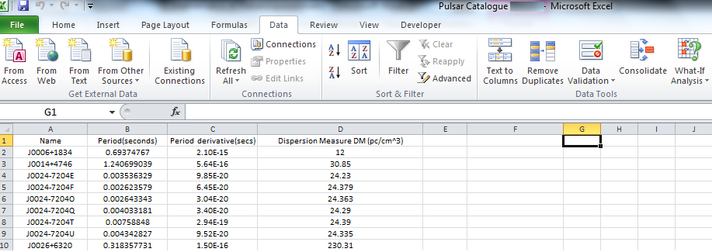

1. (a) In cell E1 Tpye “**Pulsar Ages (years)**” then press **ENTER**.

(b) In cell E2, Type the formula” **=B2/(2*C2*60*60*24*365)** then press **ENTER**

(This computes the ages in years)

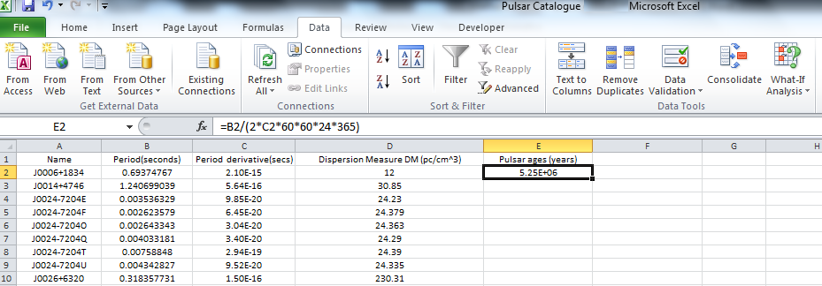

(c) Copy and fill down by dragging the cell E2 to the bottom of the table. Your spread-sheet should be similar to the one below.

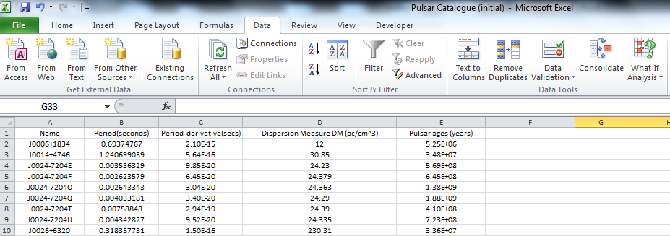

1. Sort the data by ages from largest to smallest. Highlight columns A to E by left clicking the mouse and dragging from the top of column A (on the letter A) to the top of column E (on the letter E). The columns A to E should be highlighted as shown below.

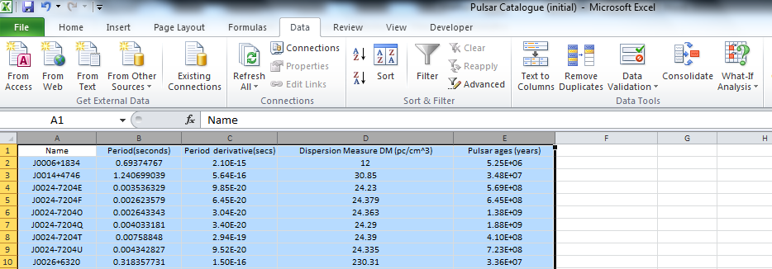

1. Click on **Data** then choose the **sort** function (circled in red below)

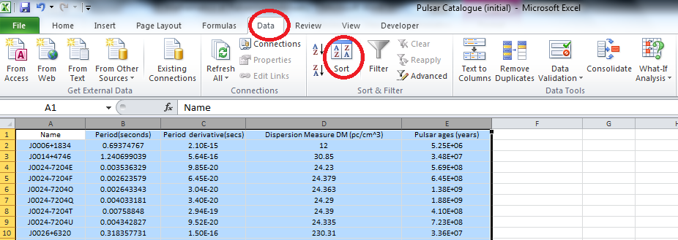

1. Choose sort by “Pulsar ages (years)” and order “Largest to Smallest”

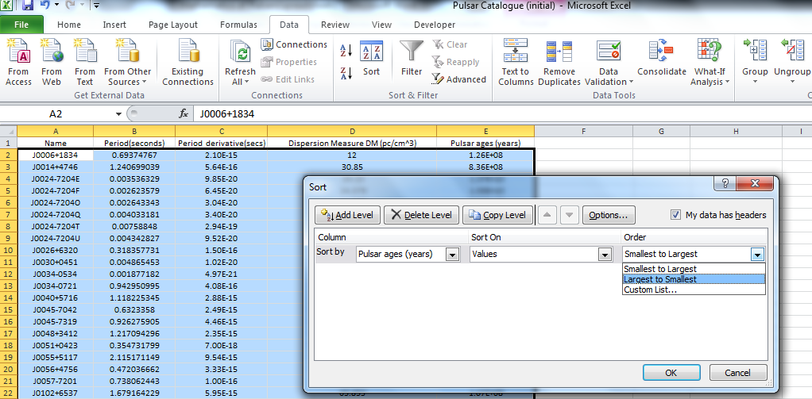

You spread-sheet should look similar to the one below. Use the sorted data to answer the questions below. Save the data to keep all changes made.

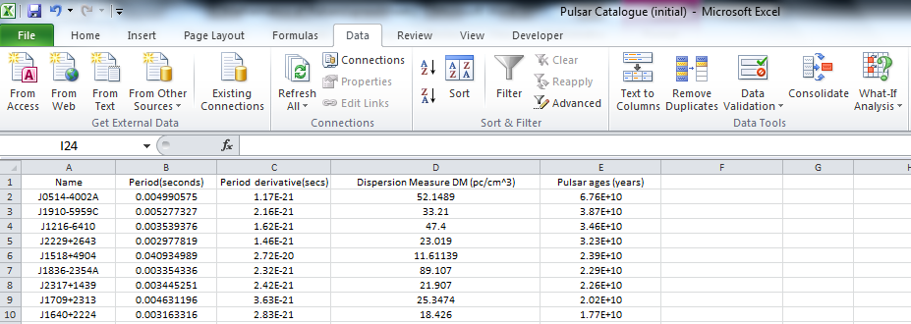

**Questions**

1. Millisecond pulsars (MSPs) have rotational periods in the range from 1 to 30 milliseconds, whereas normal pulsars have periods from 30 milliseconds to 10 seconds. Look at the 50 oldest pulsars and their periods in the sorted data. Make a conjecture about the type of pulsar these might be. (millisecond pulsars or normal pulsars)
2. How many millisecond pulsars are present in the complete spread-sheet data? Millisecond pulsars have ages in the order of 109 years or more.
3. There are a number of pulsars that appear to be millisecond pulses based on their periods; however, their ages are far too young. List three such pulsars. One of these pulsars (the youngest) is the Crab pulsar. What is the J-name, period and age of this pulsar?

***Activity 2: The Distribution of Millisecond Pulsars (MSPs)***

In this activity you will produce two scatter plots. Both will demonstrate the differences between the distribution of normal pulsars and millisecond pulsars. You will need to add three new columns to your spread-sheet. [**Log (pulsar ages)**, **Log(period) and Log(period derivatives)**]

**Scatterplot #1 Log(pulsar ages) v’s Log(period)**

**Procedure**

1. Open the excel spread-sheet file entitled ***Pulsar Catalogue***

**2.** (a) In cell F1 Tpye “**Log (pulsar ages)**” then press **ENTER**.

(b) In cell F2, Type the formula “ **=Log(E2)”** then press **ENTER**

(c) Copy and fill down by dragging the cell F2 to the bottom of the table.

1. In cell G1 Type **“Log (period)”** then press enter.
2. In cell G2 Type the formula **“=Log(B2)”**then press enter.
3. Copy and fill down by dragging the cell G2 to the bottom of the table.

You should have a spread-sheet of data similar to the one below.

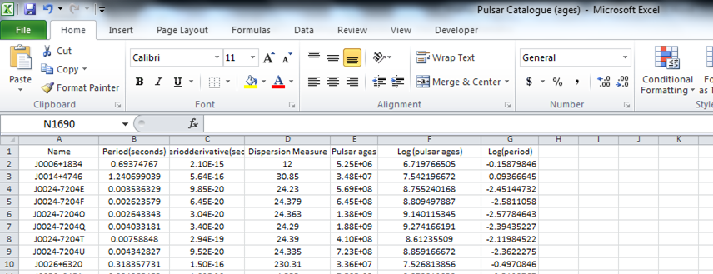

**3.** Drawing a **scatterplot** of **Log(period) v’s Log(pulsar ages)**

(a) Place the cursor at the top of column F, (on the F) then left click the mouse and drag across to column G(on the G). This should highlight all of the data in column F and column G. [The data in the left hand column- Log(pulsar ages) will be the x-axis and the right hand column- Log(period) will be the y-axis]

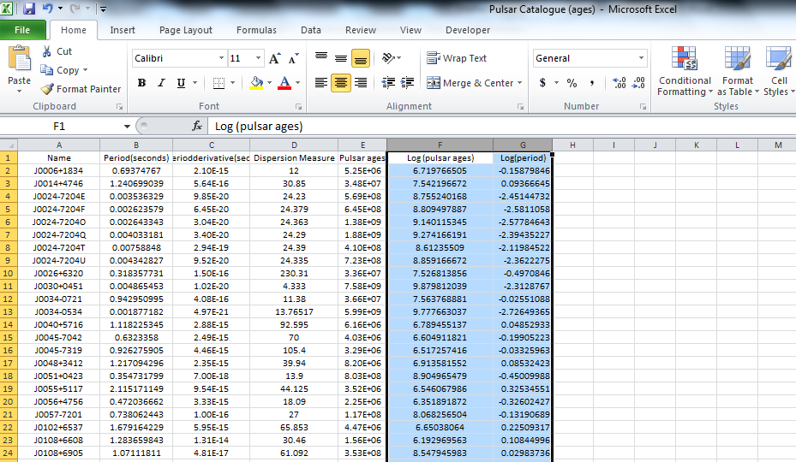

(b) To display the scatterplot, click on **insert,** then **scatter,** then choose unconnected points. (Circled in red below)

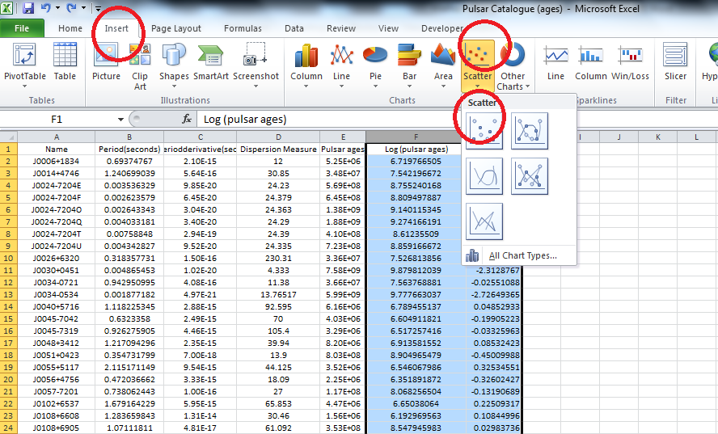

(c) The scatterplot size can be enlarged by dragging on the corners of the graph. (Circled in red)

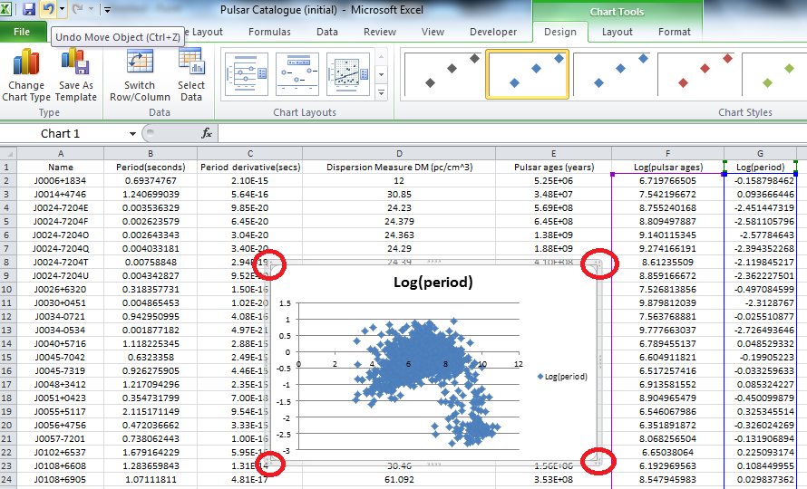

**Scatterplot #2 The P- $\dot{P }$ diagram**

**Log(period derivative) v’s Log(period)**

The course of evolution and the lifetime of a star will be determined by its initial mass. In the case of neutron stars and pulsars, the range of their masses is very small (around 1.4 solar masses) and their main source of energy is the dipole magnetic field which determines the rate of loss of rotational energy. By studying a large sample of pulsars with various rotation rates (P) and slow-down rates ($\dot{P}$), astronomers can better understand their evolutionary history. For example, individual or solitary pulsars continue to slow down and eventually decay throughout their life whereas binary pulsars speed up due to the accretion of mass from their companion to become millisecond pulsars and continue to follow a slower evolutionary process.

**Procedure**

1. Open the excel spread-sheet file entitled ***Pulsar Catalogue***

**2.** (a) In cell H1 Tpye “**Log (period derivative)**” then press **ENTER**.

(b) In cell H2, Type the formula “ **=Log(C2)”** then press **ENTER**

(c) Copy and fill down by dragging the cell H2 to the bottom of the table.

You should have a spread-sheet similar to the one below.

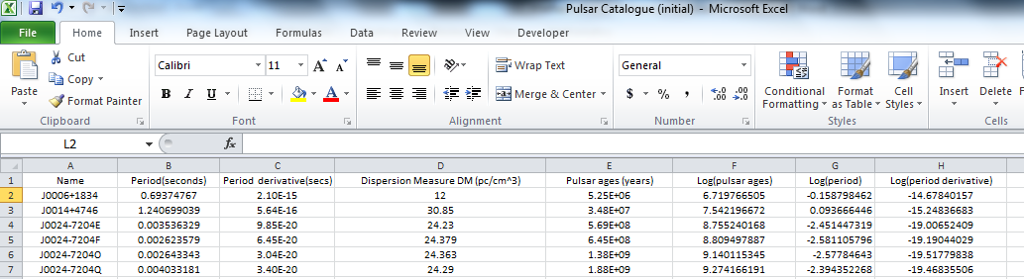

**3.** Drawing a **scatterplot** of **Log(period derivative) v’s Log(period)**

(a) Place the cursor at the top of column G, (on the G) then left click the mouse and drag across to column H(on the H). This should highlight all of the data in column G and column H. [The data in the left hand column- Log(period) will be the x-axis and the right hand column- Log(period derivative) will be the y-axis]

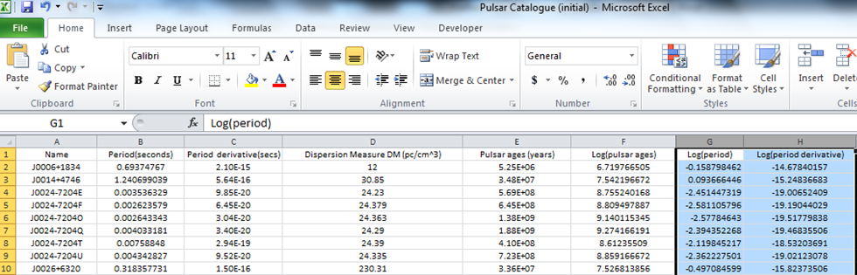

(b) To display the scatterplot, click on **insert,** then **scatter,** and then choose unconnected points.

You should have a spread-sheet similar to the one below. Don’t forget to save all the data.

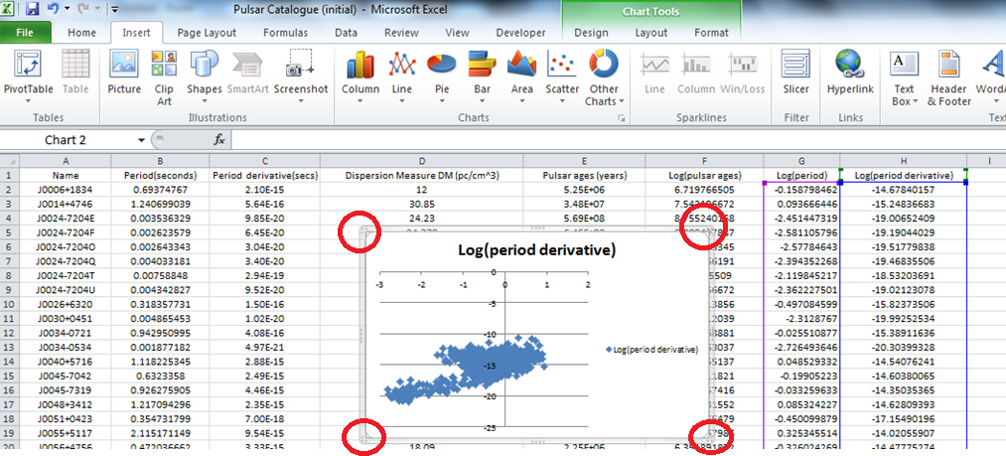

(c) The scatterplot size can be enlarged by dragging on the corners of the graph. (Circled in red above)

**Questions**

1. The log of a decimal is negative and since the periods for millisecond pulsars are less than a second, their logs will be negative. Millisecond pulsars are 109 years or older. [The log of their periods will be 9 or greater] Identify the millisecond pulsars in scatterplot #1 by drawing a box around the region in which they are situated.
2. Compare the period derivatives $\dot{P}$ (slow-down rates) of millisecond pulsars with that of normal pulsars. You can use scatterplot #2 for comparison or the **data/sort** function in excel. [Hint: Use a ratio to compare the slow-down rates]
3. The P- $\dot{P}$ diagram below contains 1,687 pulsars. The orange lines represent the magnetic field strength (in gauss), while the green lines represent the characteristic ages of pulsars in years. Questions (a) to (d) refer to the P- $\dot{P}$ diagram.

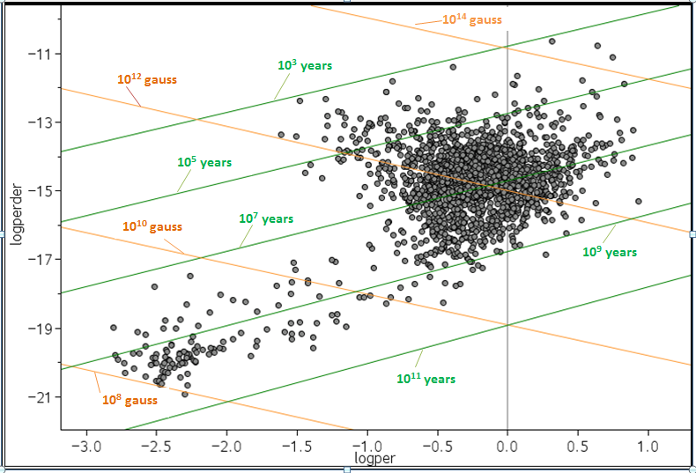

(a) In general, describe what happens to the magnetic field strength of a pulsar as it ages.

(b) Which type of pulsar (normal or millisecond) undergoes the greatest change in magnetic field strength throughout their evolution?

(c) Compare the magnetic field strength of millisecond pulsars (MSPs) to normal pulsars. Which is stronger in general?

(d) Magnetars are super-magnetized spinning neutron stars. The magnetar SGR 1900+14 has the strongest magnetic field

known in the galaxy. It is approximately 1,000,000,000,000,000 times larger than the magnetic field of the Earth which

is about 0.6 gauss. If a magnet that strong were placed halfway to the Moon, it could pull metal pens out of your pocket

on Earth. In which corner of the P- $\dot{P}$ diagram could the magnetar be located? Give a reason for your choice.

(i) Bottom left hand corner (ii) Bottom right hand corner

(iii) Top left hand corner (iv) Top right hand corner

***Activity 3: Distances of Pulsars from Dispersion Measures (DM)***

**1011 years**

**108 gauss**

In this activity you will determine the distances to pulsars based on their dispersion measures. The dispersion measure (DM) of a pulsar is a measure of the density of free electrons between an observer and the pulsar. Imagine a long tube from the observer to the pulsar with a cross sectional area of 1 square

centimetre. ( See Figure 1) The dispersion measure (DM) would be proportional to the number of free electrons inside this volume.

Various studies have shown that the number of free electrons or electron density (ne) ranges from 0.01 cm-3 to 0.2 cm-3 with an average value of 0.03 cm-3 across the galaxy. The electron density will vary depending on where a pulsar is located. For example, the radio signal from pulsars located within the galactic plane will invariably experience a greater electron density compared to the radio signals from pulsars located outside the galactic plane. HII regions between a pulsar and an observer will also increase the electron density.(See Figure 2)

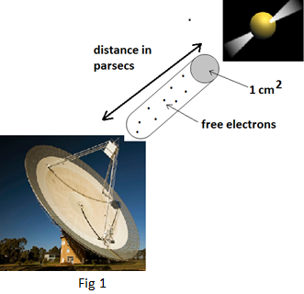

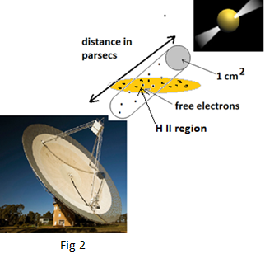

The mean electron density (ne) in figure 2 is greater than the mean electron density in figure 1 due to the presence of a H II region between the pulsar and the observer.

The dispersion measure can be observed as a broadening of an otherwise sharp pulse when a pulsar is observed over a finite bandwidth. (see Figure 3). Since radio waves are a very low [frequency](http://astronomy.swin.edu.au/cosmos/F/Frequency) oscillating electric and magnetic fields, they interact with charged particles such as protons and electrons. The electrostatic interaction between the radio waves and the charged particles causes a delay in the propagation of the radio wave, with the delay being related to the radio frequency and the masses of the charged particles. Electrons have a much greater effect than protons due to their much lower masses. The delay is inversely proportional to the mass of the charged particles and since electrons are 2,000 times smaller in mass compared to protons, the amount of dispersion is dominated by the electrons. (Astronomers usually only talk of the free electron content as being responsible for the dispersion)

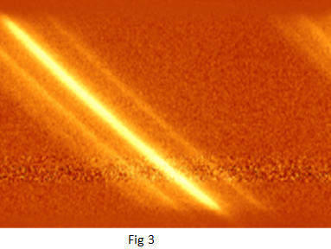

Based on the electron density (ne), the dispersion measure can be used to estimate stellar distances. The units for dispersion measure are parsecs per cubic centimetre ([pc](http://astronomy.swin.edu.au/cosmos/P/Parsec) cm-3). This makes it easy to determine the [distance](http://astronomy.swin.edu.au/cosmos/D/Distance) to a given [pulsar](http://astronomy.swin.edu.au/cosmos/P/Pulsar). By knowing the mean [electron](http://astronomy.swin.edu.au/cosmos/E/Electron) [density](http://astronomy.swin.edu.au/cosmos/D/Density) ne, the [distance](http://astronomy.swin.edu.au/cosmos/D/Distance) in parsecs *(D)* to the [pulsar](http://astronomy.swin.edu.au/cosmos/P/Pulsar) can be computed from the dispersion measure *DM*.

*DM= ne D*

$$∴ D=\frac{DM}{n_{e}}$$

[*Note: For the following activities, a mean electron density value of 0.017 cm-3 for ne has been used]

**Procedure**

1. Open the excel spread-sheet file entitled ***Pulsar catalogue***

**2.** (a) In cell I1 Tpye “**Pulsar distances (pc)”** then press **ENTER**.

(b) In cell I2, Type the formula “ **=D2/0.017”** then press **ENTER**

(c) Copy and fill down by dragging the cell I2 to the bottom of the table.

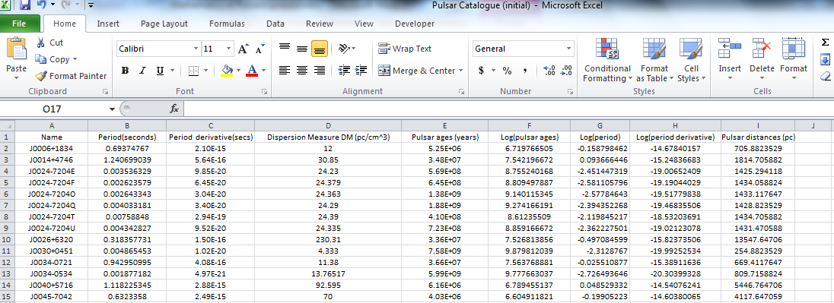

**Questions**

**1.** What is the nearest pulsar to Earth? Include the J name, distance in parsecs and light years. [Note: one parsec = 3.26 light years]

1. What is the most distant pulsar from Earth? Include the J name, distance in parsecs and light years.
2. What is the nearest millisecond pulsar to Earth? Include the J name, distance in parsecs and light years.
3. Two globular clusters have been quite fruitful in producing millisecond pulsars with periods between 2 and 6 milliseconds. The first globular cluster is 47 Tucanae which has several pulsars with a similar dispersion measure, just over 24 pc cm-3.

Use the **data/sort** function in the excel spread-sheet to group the dispersion measures from smallest to largest. Determine the J-names of the pulsars which reside in this globular cluster. [Note the J names will have the same digits in right ascension and declination; the only difference will be the last letter of the pulsar which is used to distinguish between each pulsar]

1. Find another globular cluster that has several millisecond pulsars with periods between 2 and 6 milliseconds. List the J names of all millisecond pulsars in the cluster.
2. The table below includes the dispersion measures of several pulsars which may or may not have H II regions intersecting with the line of sight of an observer on Earth. The measured distances (in parsecs) have been determined via other reliable methods.

Determine the mean electron density for each pulsar and decide whether or not the mean electron density has been increased by the pulsar signal passing through a H II region. (Use the formula *DM= ne D)*

|  |  |  |  |  |  |  |
| --- | --- | --- | --- | --- | --- | --- |
| J-Name | Period (seconds) | Period derivative  (seconds) | Dispersion measure (pc cm-3) | Distance (parsecs) | Mean electron density (*ne)* per cm3 | H II Region  Yes or No |
| J0332+5434 | 0.7145197 | 2.05E-15 | 26.833 | 2,300 |  |  |
| J0528+2200 | 3.74553925 | 4.01E-14 | 50.937 | 2,000 |  |  |
| J0534+2200 | 0.033084716 | 4.23E-13 | 56.791 | 2,000 |  |  |
| J0738-4042 | 0.374919985 | 1.62E-15 | 160.8 | 2,500 |  |  |
| J1054-5943 | 0.346908958 | 4.07E-15 | 330.7 | 6,000 |  |  |
| J1243-6423 | 0.388480921 | 4.50E-15 | 297.25 | 12,000 |  |  |
| J1640-4648 | 0.178352043 | 8.06E-16 | 474 | 5,300 |  |  |
| J2004+3137 | 2.111264734 | 7.46E-14 | 234.82 | 8,000 |  |  |
| J2113+4644 | 1.014684793 | 7.15E-16 | 141.26 | 4,300 |  |  |

**Activity 1 Answers**

**Q1.** Since these pulsars are older than 109 years and their periods are between 1 and 30 milliseconds; they are classified as millisecond pulsars.

**Q2.** There are approximately 87 millisecond pulsars in the data. [The selected millisecond pulsars have periods less than or equal to 0.03 seconds and an approximate age of 109 years or more]

**Q3.** J0534+2200 has a period of 0.0331 seconds and has a characteristic age of 1,240 years. This is the famous Crab pulsar.[The Crab pulsar first appeared as a supernova remnant in 1054, so its actual age is 958 years].

J2022+3842 has a period of 0.0243 seconds and is approximately 8,920 years old.

J1400-6325 has a period of 0.031 seconds and is approximately 12,700 years old.

**Activity 2 Answers**

**Q1.** The box contains y-values below -1.52 i.e. log(.03) and x-values above 9.

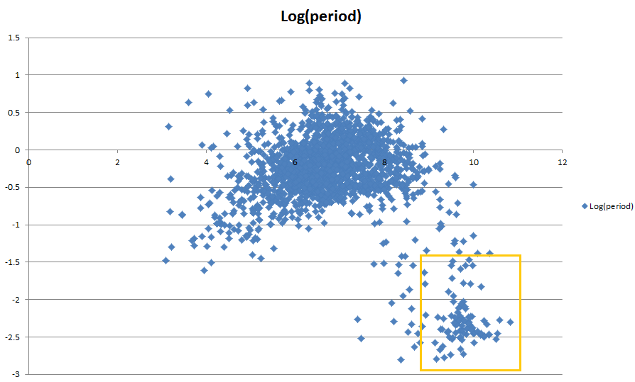

**Q2.** The period derivatives $\dot{P}$ (slow-down rates)ofmillisecond pulsars (shown in the red box) are much smaller than normal pulsars.

On average the slow-down rates are smaller by a factor of 105. [10-15 for normal pulses as opposed to 10-20 for MSPs]

**Q3. (a)** The magnetic field strength of a pulsar decreases over time.

**(b**) Normal pulsars range from 1014 gauss to 1010 gauss throughout their evolution. Millisecond pulsars range from 1010 gauss to 108 gauss throughout their evolution.

**(c)** Millisecond pulsars have a magnetic field strength between 108 and 1010 gauss. Normal pulsars have a magnetic field strength

of approximately 1012 gauss. Normal pulsars are approximately 1,000 times stronger.

**(d)** Top right hand corner. The magnetic field strength of magnetars is 1014 gauss or more.

**Activity 3 Answers**

**Q1.** J0108-1431, 140 parsecs, 457.8 light years

**Q2.** J1746-2849, 85,647.06 parsecs, 280,065.88 light years

**Q3.**  J0437-4715, 155.57 parsecs, 508.73 light years

**Q4.** **Q5.**

|  |  |
| --- | --- |
| J Name | Dispersion Measure  (pc cm-3) |
| J2129+1210G | 66.4 |
| J2129+1210E | 66.51 |
| J2129+1210C | 67.13 |
| J2129+1210B | 67.69 |

|  |  |
| --- | --- |
| J Name | Dispersion Measure  (pc cm-3) |
| J0024-7204E | 24.23 |
| J0024-7204Q | 24.29 |
| J0024-7204U | 24.33 |
| J0024-7204O | 24.36 |
| J0024-7204T | 24.39 |

**Q6.**

|  |  |  |  |  |  |  |
| --- | --- | --- | --- | --- | --- | --- |
| J-Name | Period (seconds) | Period derivative (seconds) | Dispersion measure  (pc cm-3) | Distance (parsecs) | Mean electron density (*ne)*per cm3 | H II Region  Yes or No |
| J0332+5434 | 0.7145197 | 2.05E-15 | 26.833 | 2,300 | 0.011667 | no |
| J0528+2200 | 3.74553925 | 4.01E-14 | 50.937 | 2,000 | 0.025469 | no |
| J0534+2200 | 0.033084716 | 4.23E-13 | 56.791 | 2,000 | 0.028396 | no |
| J0738-4042 | 0.374919985 | 1.62E-15 | 160.8 | 2,500 | 0.06432 | yes |
| J1054-5943 | 0.346908958 | 4.07E-15 | 330.7 | 6,000 | 0.55117 | yes |
| J1243-6423 | 0.388480921 | 4.50E-15 | 297.25 | 12,000 | 0.024771 | yes |
| J1640-4648 | 0.178352043 | 8.06E-16 | 474 | 5,300 | 0.089434 | yes |
| J2004+3137 | 2.111264734 | 7.46E-14 | 234.82 | 8,000 | 0.029353 | no |
| J2113+4644 | 1.014684793 | 7.15E-16 | 141.26 | 4,300 | 0.032851 | yes |